**Faderanga, Janrey Cyril C.**

**Proffesional Development 5**

**BSIT3I**

**April 12 2024**

Name of Guest Speaker: Mr JoshuaTigno

Title of the Topic : 13TH IT summit : : Tech solutions. Human Evolution. Future Evolution

PHOTO GALLERY

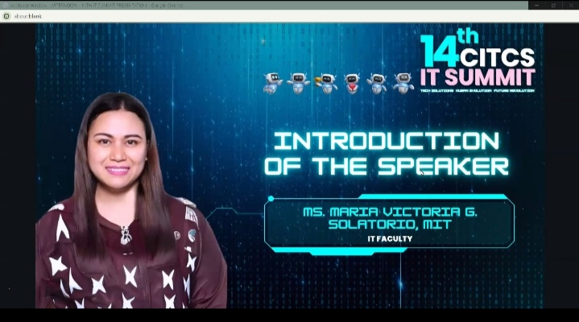

Name of person giving welcome remarks

**Ms. Maria Victoria Solatorio**

Content of his / her welcome remarks (not less than 5 sentences)

**Lorem ipsum dolor sit amet, consectetur adipiscing elit, sed do eiusmod tempor incididunt ut labore et dolore magna aliqua. Ut enim ad minim veniam, quis nostrud exercitation ullamco laboris nisi ut aliquip ex ea commodo consequat. Duis aute irure dolor in reprehenderit in voluptate velit esse cillum dolore eu fugiat nulla pariatur. Excepteur sint occaecat cupidatat non proident, sunt in culpa qui officia deserunt mollit anim id est laborum.**

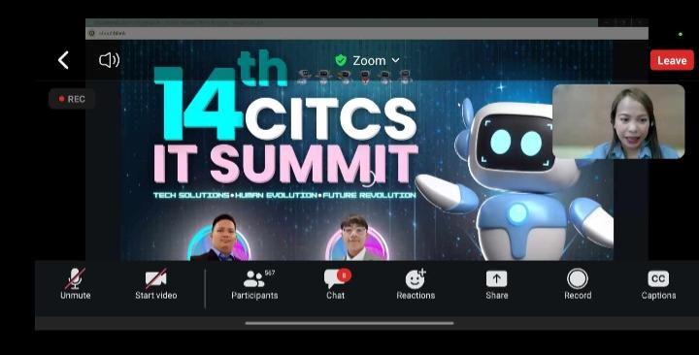

Name of person giving inspirational message

Content of his / her welcome remarks (not less than 5 sentences)

**Envision yourselves as pioneers of technological progress, embarking on a journey to surpass the challenges of a new frontier.**

**Embrace each obstacle as an opportunity for innovation, knowing that within every challenge lies the seed of breakthrough.**

**Lorem ipsum dolor sit amet, consectetur adipiscing elit, sed do eiusmod tempor incididunt ut labore et dolore magna aliqua. Ut enim ad minim veniam, quis nostrud exercitation ullamco laboris nisi ut aliquip ex ea commom**.**Together, we forge ahead, inspired by the belief that through trailblazing technology, we not only meet the challenges of today but also shape a future where the impossible becomes the achievable.**

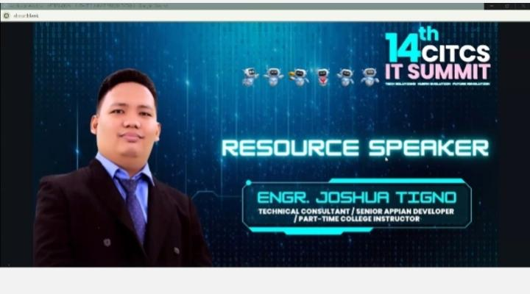

Name of person giving Introduction to the Guest Speaker

**Eng. Joshua Tigno**

Give at least five credentials / achievements of the guest speaker

1. **cloud service expert**
2. **Graduate of Masters In information Technology program at Pamantasan Lungsod Ng Muntinlupa**
3. **Possessive extensive skills ang has accumulated over 6 years of experienced in the IT sector**
4. **Advanced Cloud engineer**
5. **Microsoft Certified**

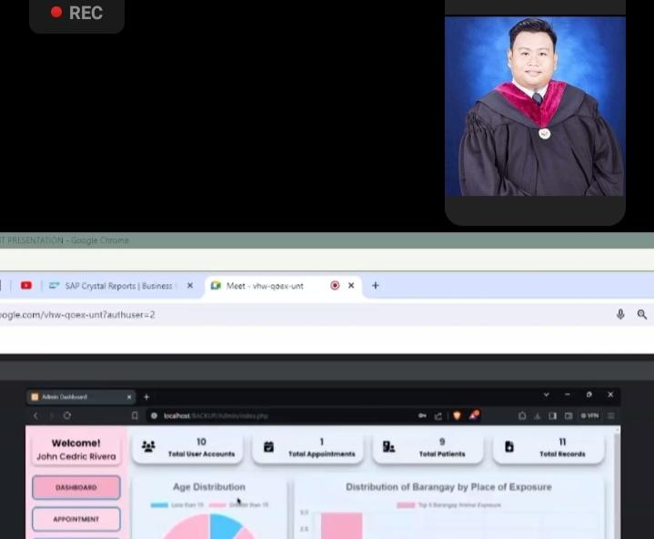

Name of the Guest Speaker

**Mr. Steven Barizo**

Critical Learning Areas learned about (Give at least 5 learnings)

**Firstly, participants delve into cutting-edge innovations, emphasizing the need to stay at the forefront of technological advancements.**

**Secondly, the summit emphasizes strategic problem-solving, encouraging attendees to develop adaptive approaches for navigating the ever-evolving landscape of IT challenges.**

**Thirdly, there is a spotlight on collaboration, recognizing that the synergy of diverse minds is essential for conquering complex problems. Fourthly, participants engage in discussions on ethical considerations, ensuring that technological advancements align with responsible and sustainable practices.**

**Finally, the summit emphasizes continuous learning, urging IT professionals to embrace a mindset of lifelong learning to stay ahead in the rapidly changing field of technology.**

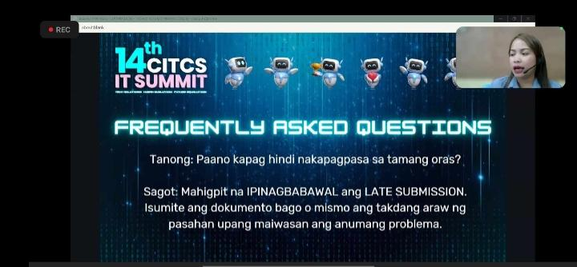

Name of the Person facilitating the Q and A

Give at least 3 questions raised and how it was answered by the guest speaker

**Question 1: Paano po kayo nagiging update don the latest advancements and emerging technologies in cloud computing?**

**With his confidence, he shared the words like this: Staying updated in this ever-evolving field is crucial. He finds that his confidence in what he does and his genuine passion for the work keep him driven. Also, continuous learning is key. He makes it a point to engage with industry forums, attend conferences, and collaborate with experts. It’s this combination of confidence, passion, and a commitment to learning that helps him stay on top of the latest advancements in cloud computing.**

**Question 2: In terms of predicting the future, how do you think cloud computing could run in the future?**

**As I remember, Mr. Briones responded like predicting the future is always a bit challenging, but right now, we are undeniably shaping the future with cloud computing. It’s not just a trend; it’s a pivotal part of how we navigate the digital landscape. The future, in a sense, is happening now. And cloud computing is the) forefront of this transformative journey.**

**Question 3: In your own perspective, what’s your stand on those companies transitioning slowly into Al?**

**Mr. Briones considered the question like, transitioning into Al is a significant step, and the pace Pageles. It’s 7 distend that 1: everyone can make the leap overnight. His perspect pragmatic. It’s crucial for companies to assess their readiness, understand the implications, and proceed at a pace that aligns with their capabilities and goals. A gradual transition allows for a more thorough integration of Al technologies, ensuring sustainable growth and innovation.**

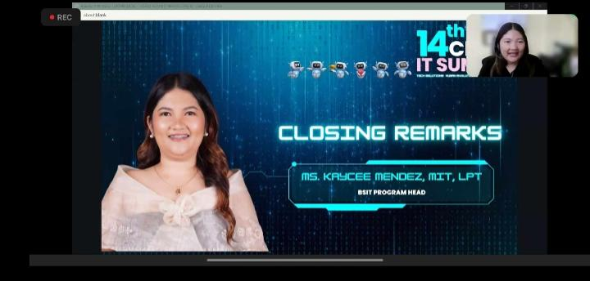

Name of person giving closing remark

**Ms. Kaycee Mendez**

Content of his / her closing remarks (not less than 5 sentences)

**In stepping up to deliver the closing remarks, Mr. Esguerra demonstrated both adaptability and leadership, seamlessly taking on a role originally assigned to another. His advice to the IT Summit attendees resonated with wisdom, emphasizing the perpetual nature of learning. Acknowledging the insightful words of the guest speaker, he underscored the idea that the journey of knowledge is an ongoing process, where each endpoint merely marks the beginning of a new chapter. The poignant metaphor of a small walk of learning every day encapsulates the incremental yet continuous nature of personal and professional growth. In concluding his remarks, Mr. Esguerra expressed gratitude to all attendees, leaving them with a heartfelt wish for continuous blessings from above.**

**REFLECTION**

What are the learnings you acquired during the seminar? Give at least 5 key learnings

1. **_ As a student attending the 13th IT Summit, immerse yourself in a rich learning experience focused on trailblazing technology and overcoming challenges on the new frontier.**
2. **Engage with cutting-edge innovations presented during the seminars, gaining firsthand exposure to the forefront of IT advancements.**
3. **Participate actively in discussions and collaborative sessions to refine your strategic problem-solving skills, essential for navigating the dynamic landscape of information technology.**
4. **Cultivate meaningful connections with industry professionals and fellow students, recognizing the significance of collective intelligence in addressing complex issues.**
5. **Lastly, approach the summit with a keen awareness of the ethical considerations surrounding technological advancements, ensuring that your learning extends beyond innovation to responsible and sustainable practices in the IT industry**

How do you think you can apply these learnings as an IT Professional in the near future?

Give at least 5 sentences

**As a student, I see the application of the learnings from the 13th IT Summit as integral to my future as an IT professional.**

**The exposure to cutting-edge innovations will empower me to contribute to and stay at the forefront of technological advancements in my chosen field.**

**The honed strategic problem-solving skills acquired during seminars will be invaluable in addressing the ever-evolving challenges that characterize the IT landscape.**

**The connections established with industry professionals and peers will serve as a foundation for collaborative efforts, fostering a network that supports mutual growth and shared knowledge.**

**Moreover, the emphasis on ethical considerations will guide my decision-making, ensuring that my contributions align with responsible and sustainable practices in the fast-paced world of information technology.**

**Overall, the summit provides a solid framework for continuous learning and application, preparing me to navigate and contribute effectively to the dynamic field of IT in the near future.**

**By applying this learning, how do you think we can make this happen? (Cite what will be the contribution of the institution and what will be the contribution of the student?)**

**As a student, applying the learnings from the 13th IT Summit involves a collaborative effort between the institution and myself. The institution can contribute by integrating the latest technologies into the curriculum, ensuring that students are exposed to cutting-edge innovations. Faculty engagement with industry experts can provide students with real-world insights and opportunities for hands-on learning. The institution can also facilitate networking events and industry partnerships, creating avenues for students to connect with professionals in the field.**

**On my part, as a student, I can actively engage in these opportunities, seeking internships, attending networking events, and participating in collaborative projects. Continuous self-learning and staying updated with industry trends will be my contribution, ensuring that I bring fresh perspectives and relevant knowledge to the table. Additionally, by upholding ethical standards and promoting responsible technology use, I can contribute to a culture of innovation that aligns with sustainable practices. Together, the institution and I can create an environment where theoretical knowledge meets practical application, preparing me for a successful transition into the dynamic realm of IT as a future professional.**